
NAME: prawin sankar
REG.NO:192524002
COURSE CODE:CSA1514

Exp.No:01

1.Create a simple cloud software application for Flight Reservation System using any Cloud Service Provider to demonstrate SaaS
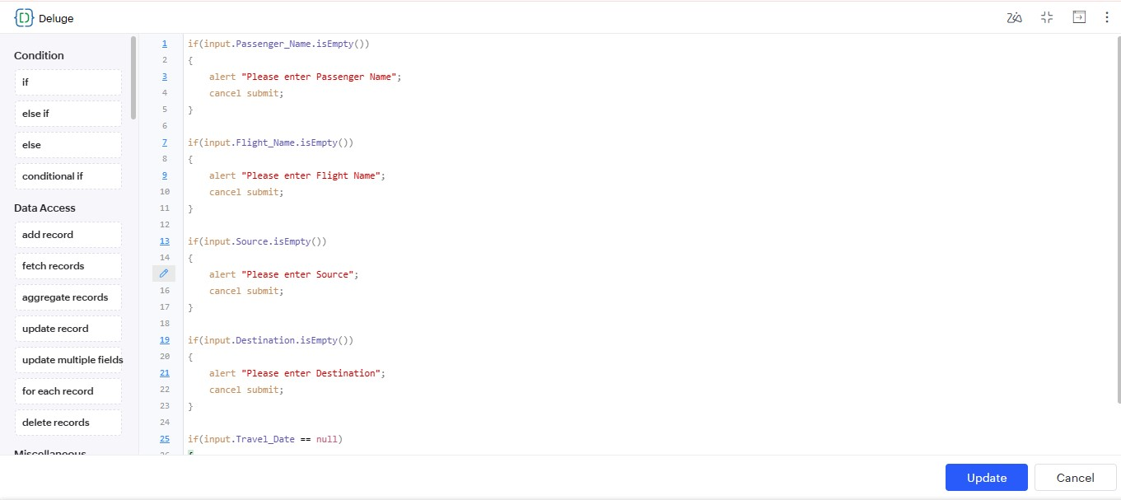

results:

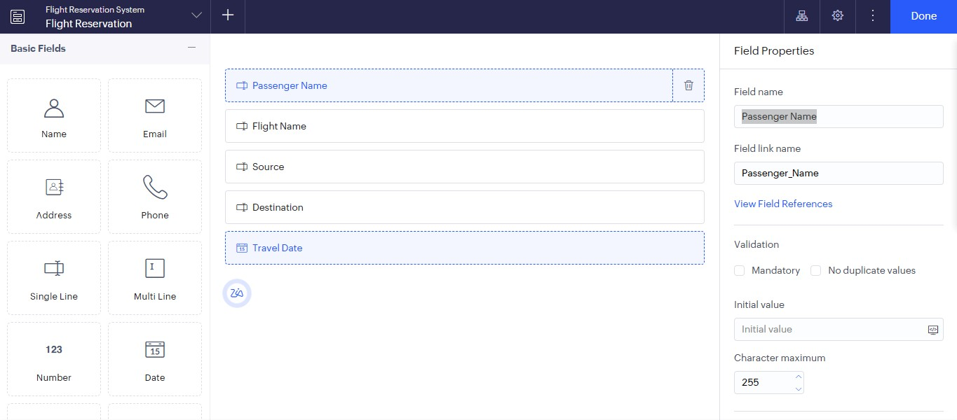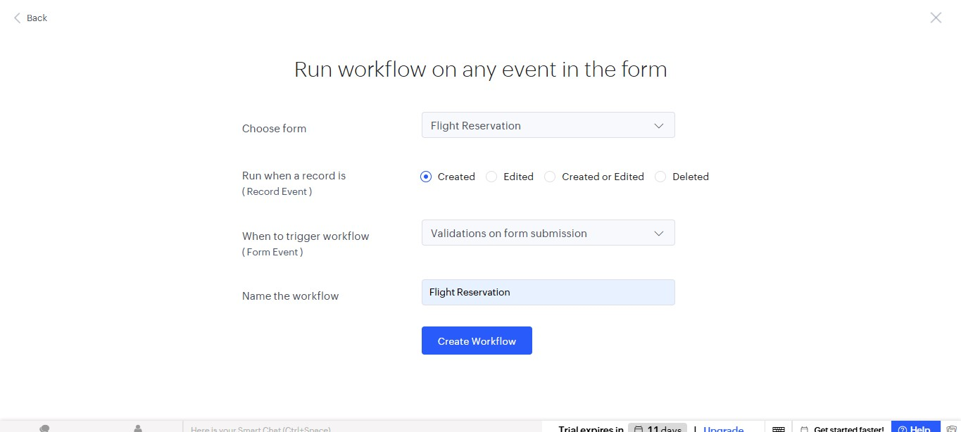

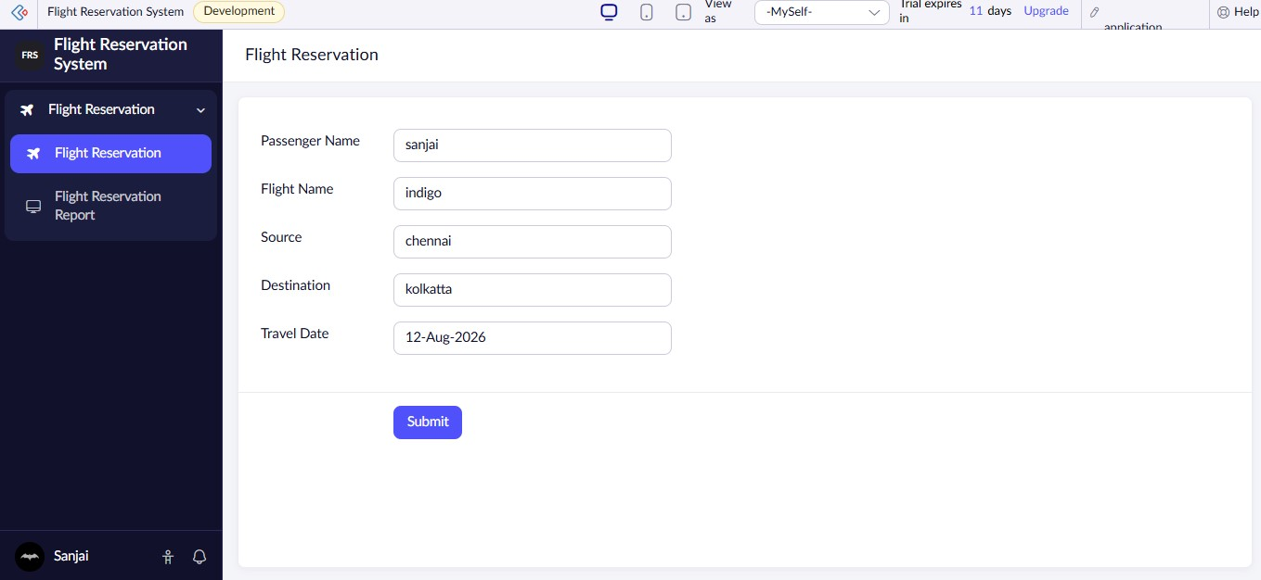

CODE:
if(input.Passenger_Name.isEmpty())
{
alert "Please enter Passenger Name"; cancel submit;
}

if(input.Flight_Name.isEmpty())
{
alert "Please enter Flight Name"; cancel submit;
}

if(input.Source.isEmpty())
{
alert "Please enter Source"; cancel submit;
}

if(input.Destination.isEmpty())
{
alert "Please enter Destination"; cancel submit;
}

if(input.Travel_Date == null)
{
alert "Please select Travel Date"; cancel submit;
}

